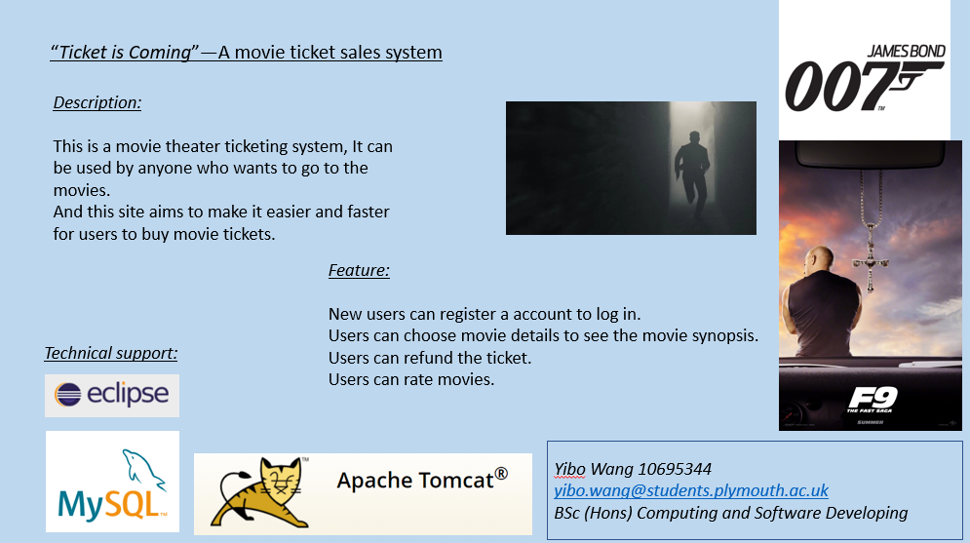

With the rapid development of society, people's pursuit of spirituality is increasing day by day, or go to travel, or to see idol performances, or read a good book, but more and more people choose to watch a movie. Because in this way, you can not only get in touch with new things, but also leave good memories with friends or family. However, due to busy work and the rapid development of the Internet, in order to make it easier for the public to purchase movie tickets, so movie fans can have more options for buying tickets. Online movie ticket purchase is a more appropriate choice than the on-site ticket purchase method.

This system is an online movie ticketing system that can provide users with a convenient online booking environment. It mainly realizes the functions of user registration, login, query, purchase of movie tickets, and refunds. Through the background management module, the management functions of users and movies can be realized. This system uses eclipse as the development environment, uses the Java language, and uses MySQL as the system database for development. The entire website has a friendly interface and simple operation.